3&4 Install Apache and run Apache on port number 81  
 Deploy a sample index.html file on Apache

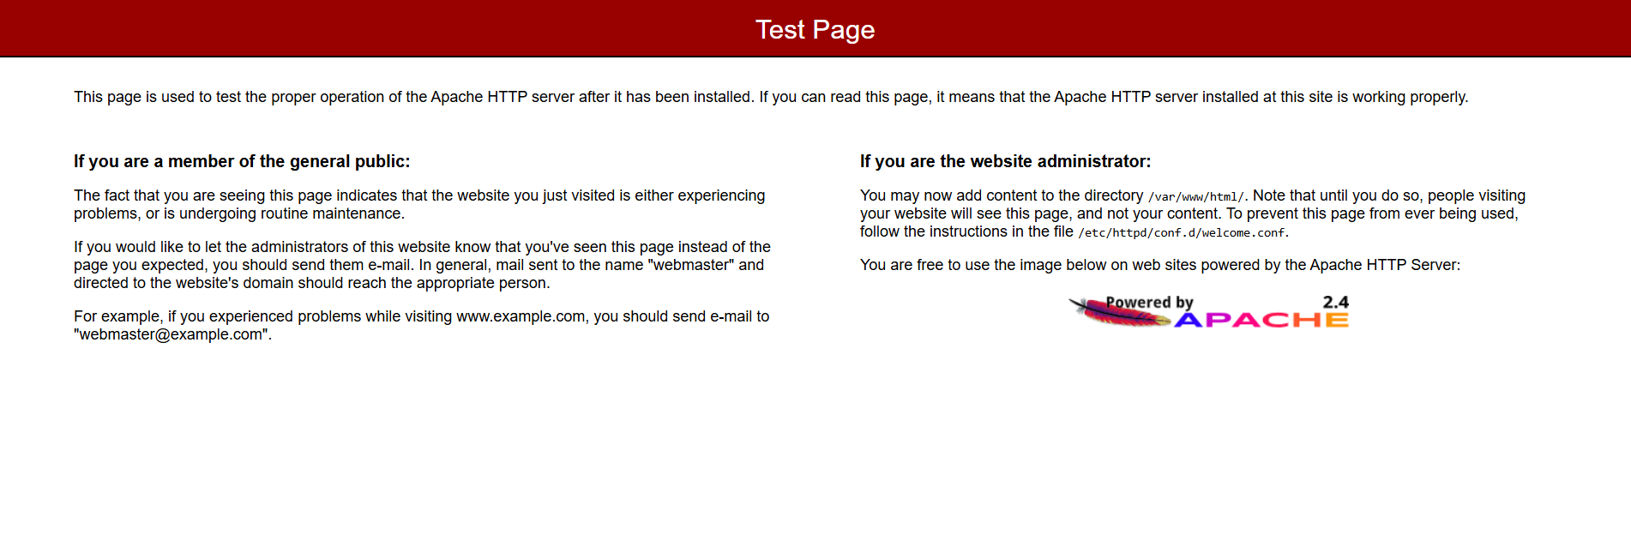

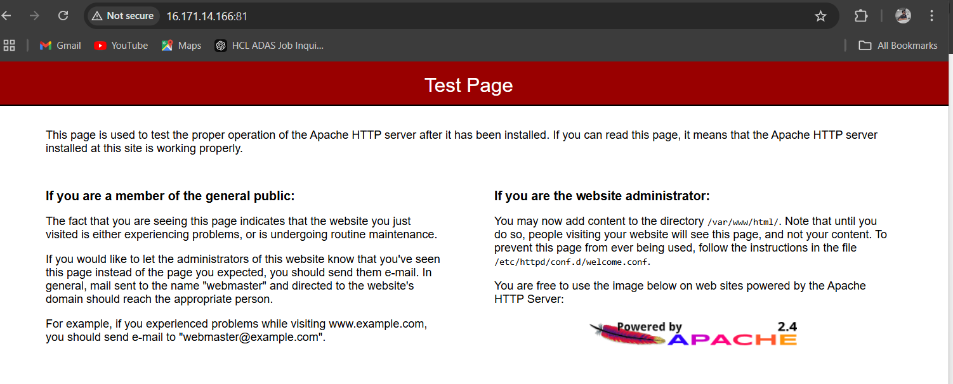

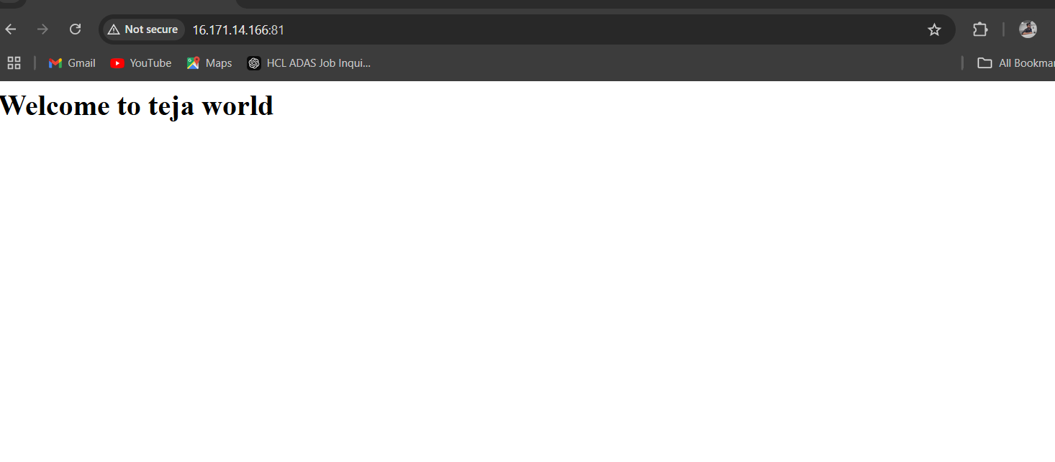

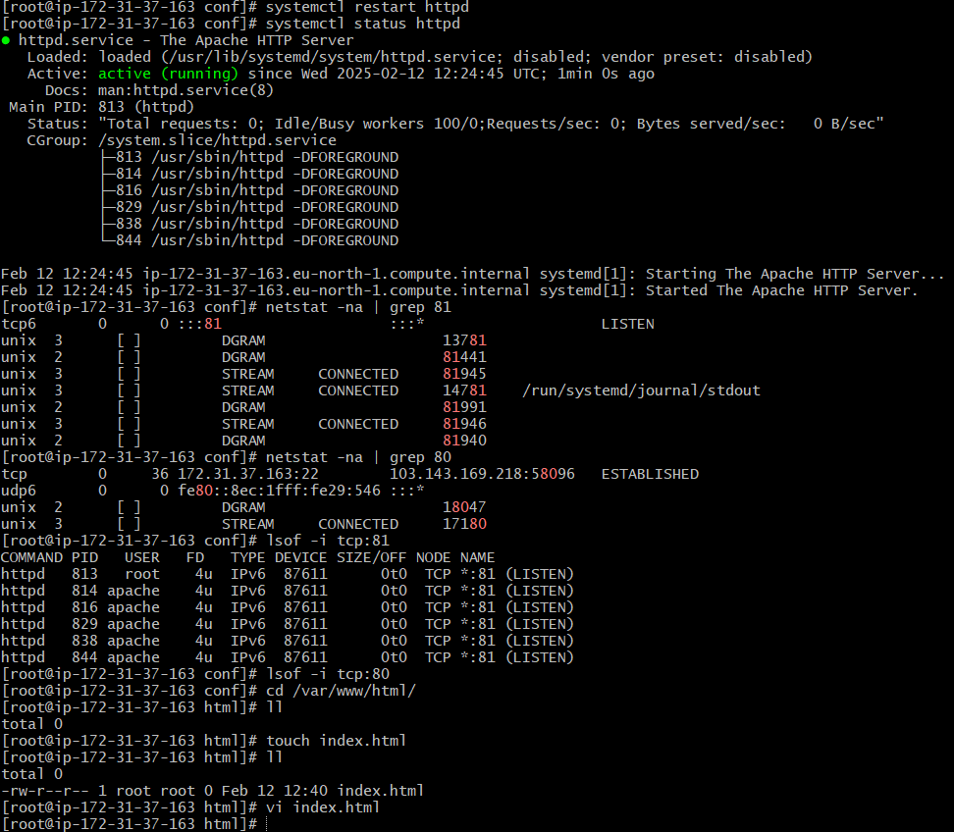

1&2) Install nginx and run nginx on port number 82  
 Deploy a sample index.html file on nginx.

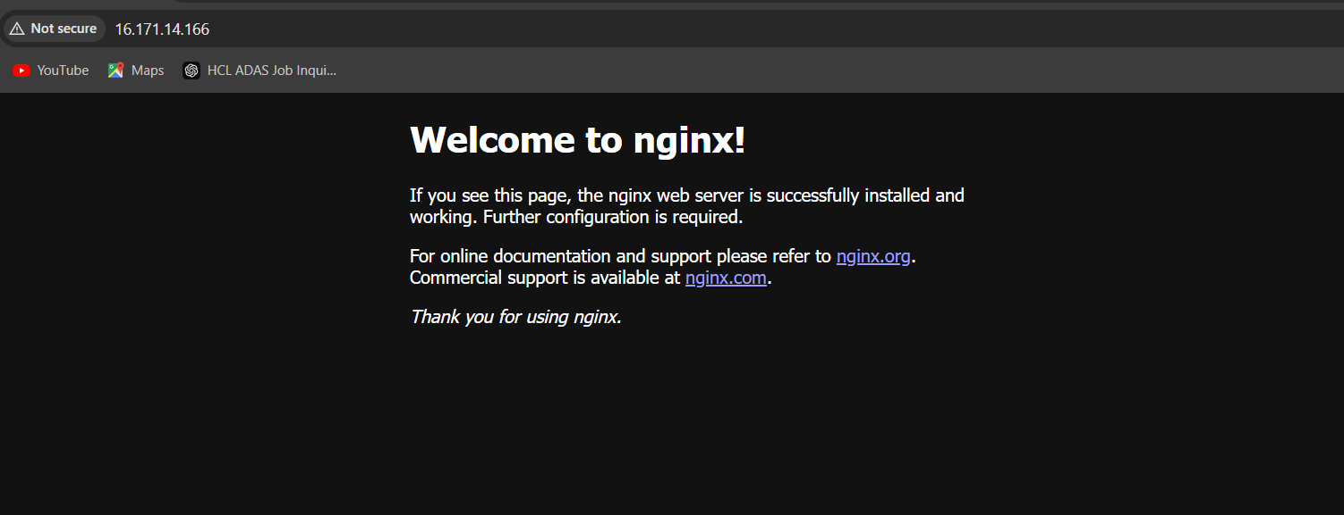

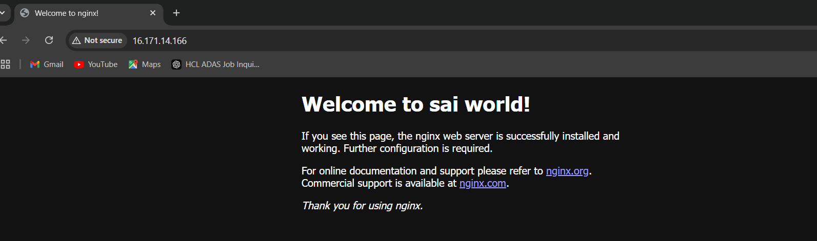

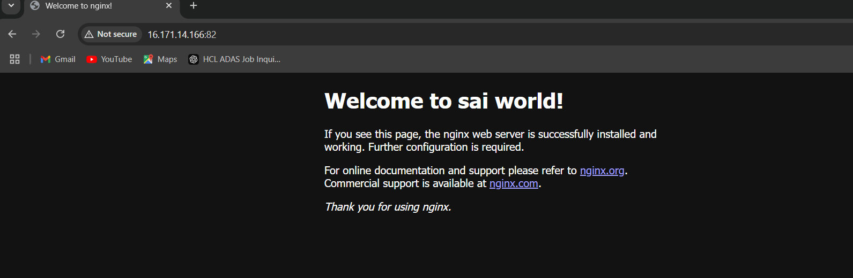

5) Install Apache tomcat on port number 8082

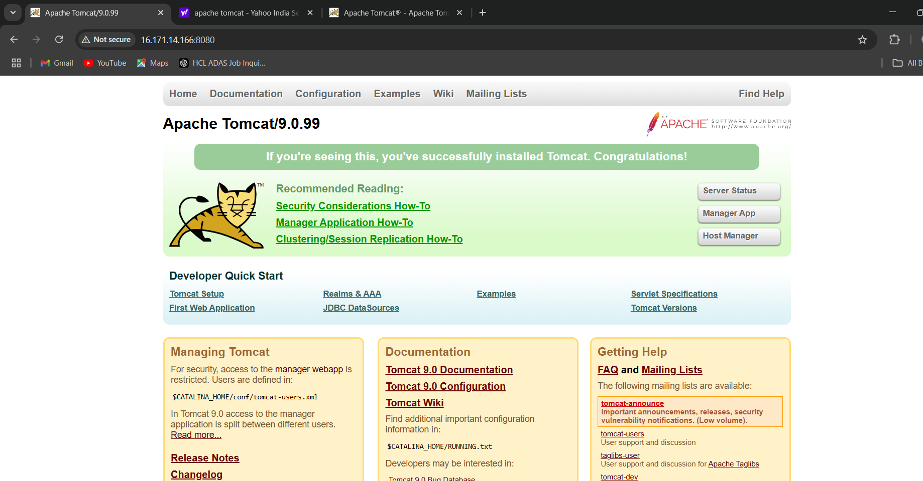

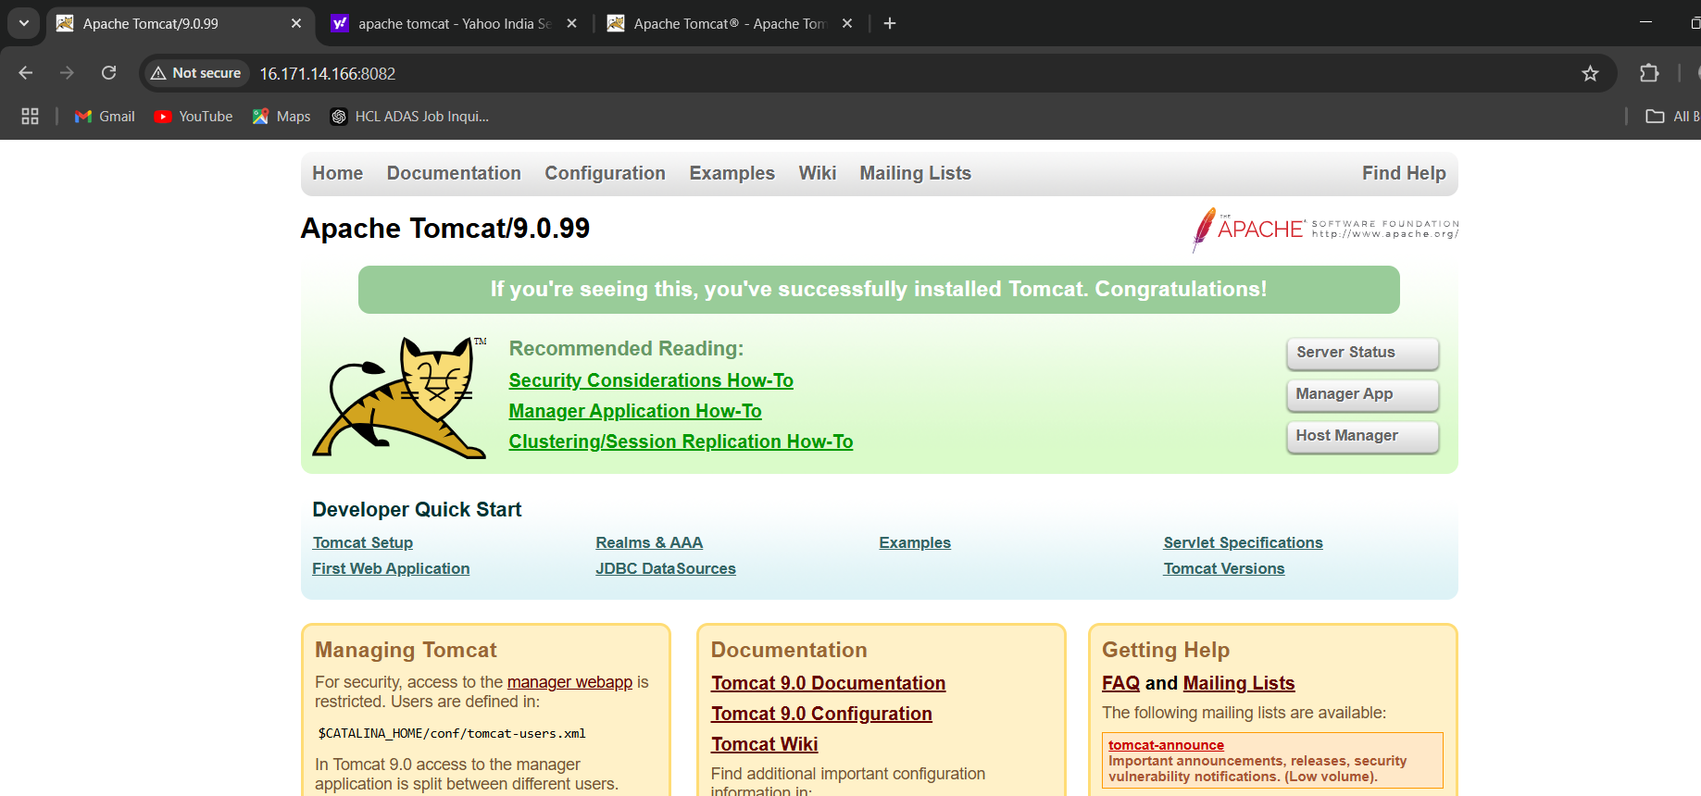

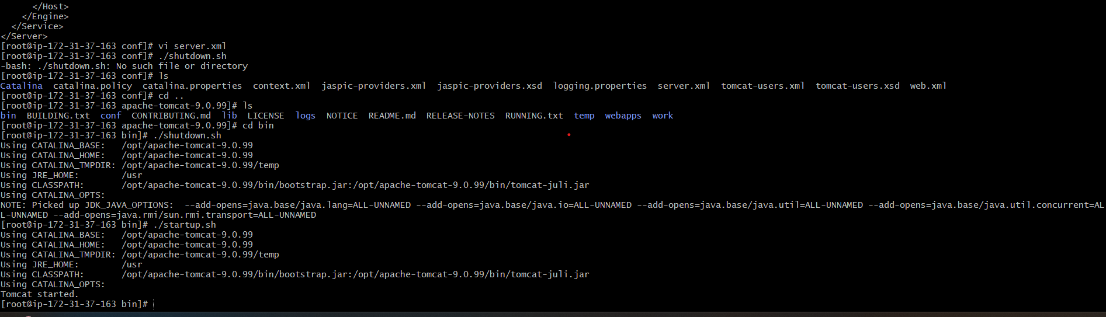

6) Deploy a sample app on webapps

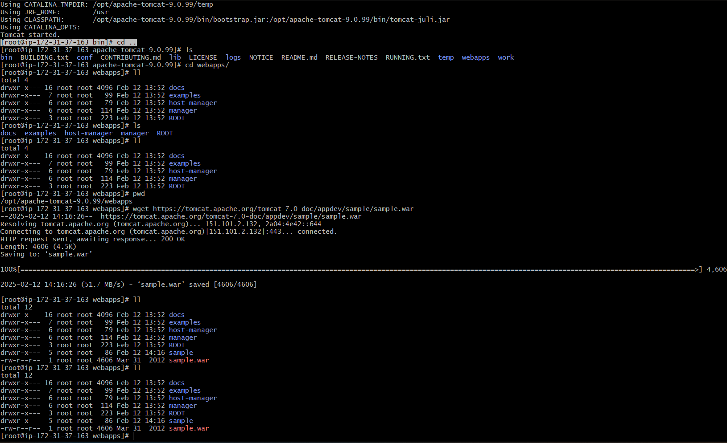

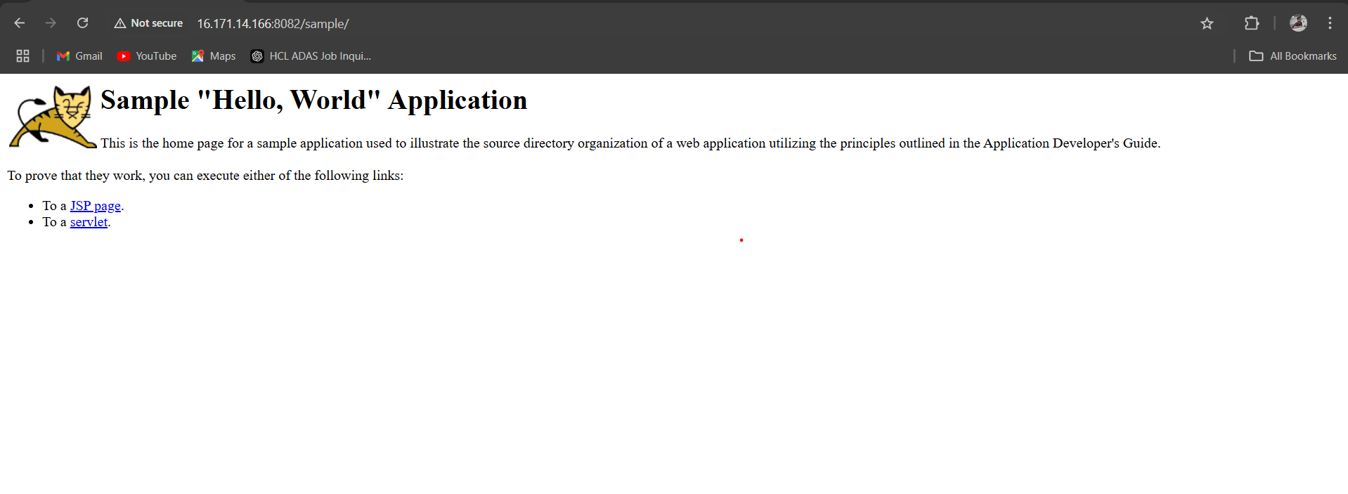

7) Create a tomcat.service file for tomcat.

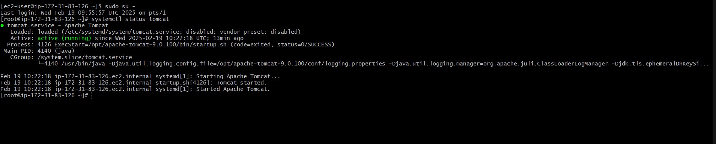

8) Configure HA Proxy server

